Name: Kaveri Avinash Jarhad
Shubhangi Balaji Khavle
Assignemnt 5

Set enable password and enable secret password on the router and verify
encryption. Also set a console password and access the router from a PC.

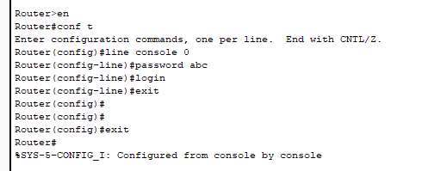

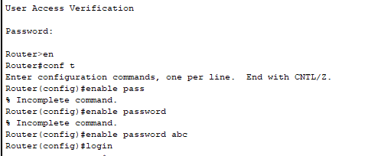

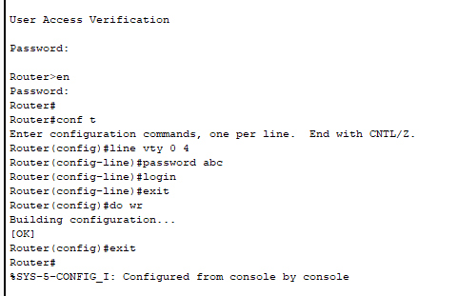
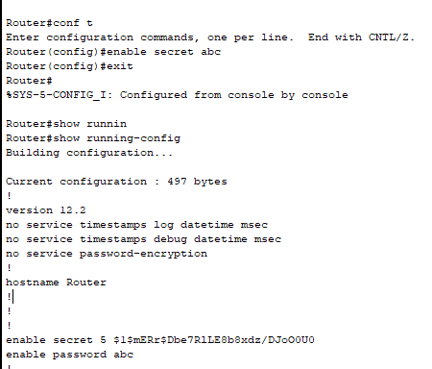
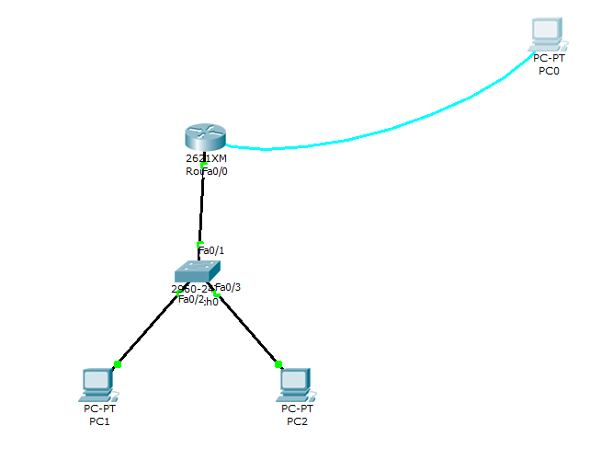

Assignment 6
Question 1
Three routers are connected in a line; each router has two switches, and each
switch has two PCs. Configure Static Routing and RIP so that all PCs can
communicate.
TOPOLOGY:
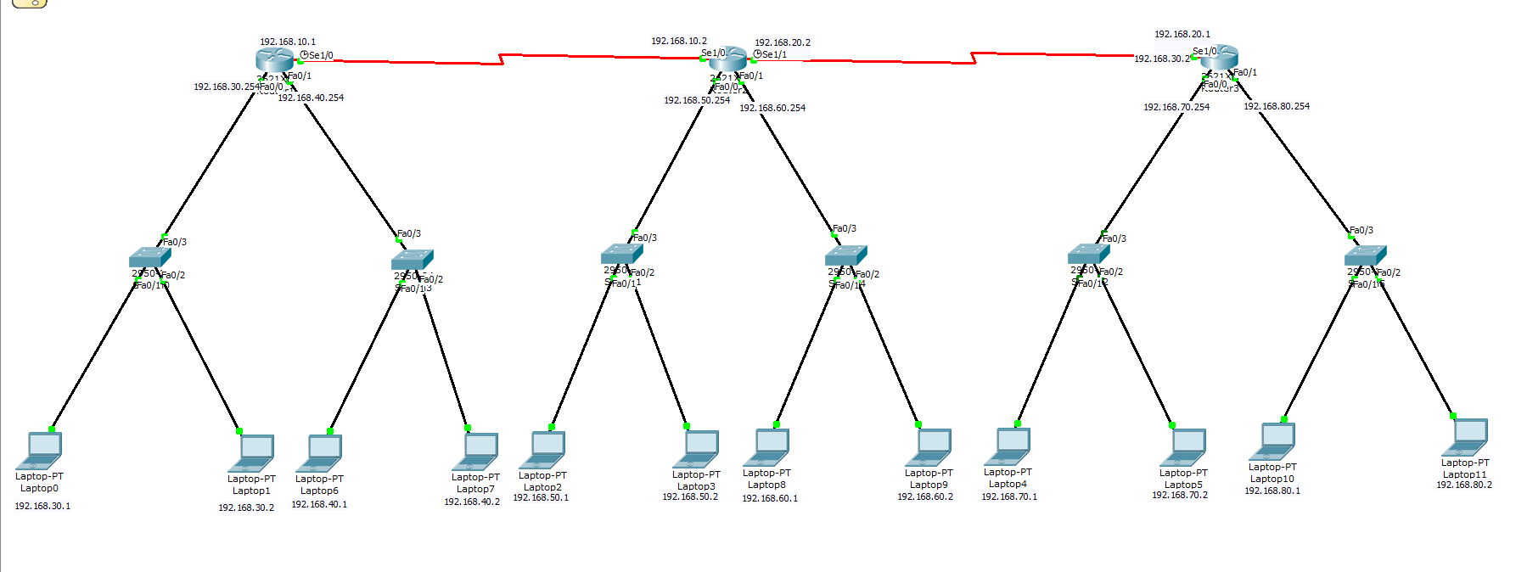

- STATIC ROUTING
For Router 1:
>enable
#configure terminal
(config)# interface fastEthernet 0/0
(config-if)# no shutdown
(config-if)# ip address 192.168.30.0 255.255.255.0
(config)# interface fastEthernet 0/1
(config-if)# no shutdown
(config-if)# ip address 192.168.40.0 255.255.255.0
(config)# interface serial 1/0
(config-if)# no shutdown
(config-if)# ip address 192.168.10.1 255.255.255.0

(config)# ip route 192.168.50.0 255.255.255.0 192.168.10.2
(config)# ip route 192.168.60.0 255.255.255.0 192.168.10.2
(config)# ip route 192.168.70.0 255.255.255.0 192.168.10.2
(config)# ip route 192.168.80.0 255.255.255.0 192.168.10.2
(config)# ip route 192.168.20.0 255.255.255.0 192.168.10.2

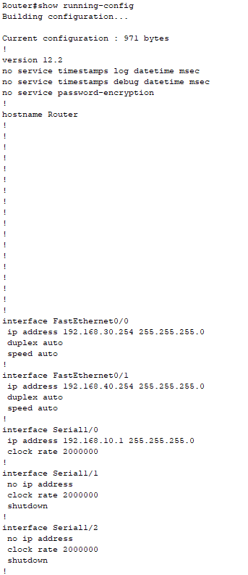

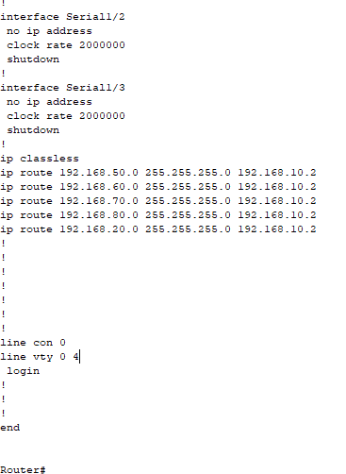

For Router 2:
>enable
#configure terminal
(config)# interface fastEthernet 0/0
(config-if)# no shutdown
(config-if)# ip address 192.168.50.0 255.255.255.0
(config)# interface fastEthernet 0/1
(config-if)# no shutdown
(config-if)# ip address 192.168.60.0 255.255.255.0
(config)# interface serial 1/0
(config-if)# no shutdown
(config-if)# ip address 192.168.10.1 255.255.255.0
(config)# interface serial 1/1
(config-if)# no shutdown
(config-if)# ip address 192.168.20.2 255.255.255.0

(config)# ip route 192.168.30.0 255.255.255.0 192.168.10.2
(config)# ip route 192.168.40.0 255.255.255.0 192.168.10.2
(config)# ip route 192.168.70.0 255.255.255.0 192.168.10.2
(config)# ip route 192.168.80.0 255.255.255.0 192.168.10.2

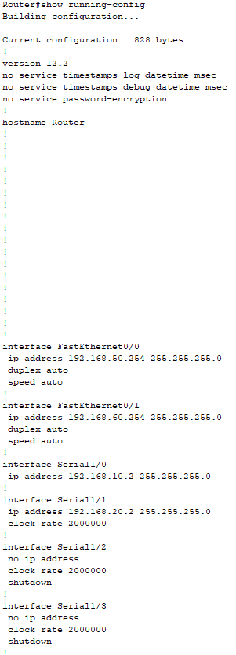

For Router 3:

>enable
#configure terminal
(config)# interface fastEthernet 0/0
(config-if)# no shutdown
(config-if)# ip address 192.168.70.0 255.255.255.0
(config)# interface fastEthernet 0/1
(config-if)# no shutdown
(config-if)# ip address 192.168.80.0 255.255.255.0
(config)# interface serial 1/1
(config-if)# no shutdown
(config-if)# ip address 192.168.20.1 255.255.255.0

(config)# ip route 192.168.30.0 255.255.255.0 192.168.10.1
(config)# ip route 192.168.40.0 255.255.255.0 192.168.10.1
(config)# ip route 192.168.50.0 255.255.255.0 192.168.10.1
(config)# ip route 192.168.60.0 255.255.255.0 192.168.10.1
(config)# ip route 192.168.10.0 255.255.255.0 192.168.10.1

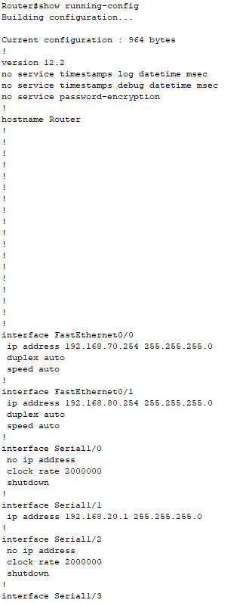

- RIP:
Router1:
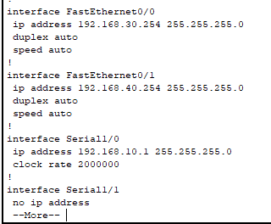
Router 2:
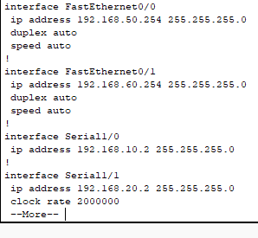
Router 3:
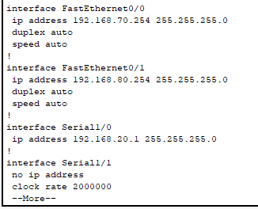
Ping from PC 1 to PC 6
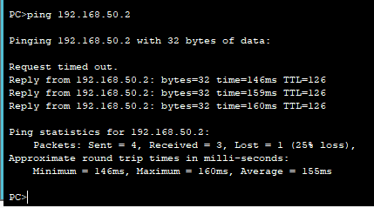
Ping from PC 1 to PC 12
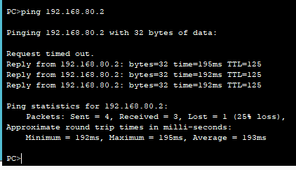

Question 2
Three routers are connected in a line; each router has two switches, and each
switch has two PCs. Configure EIGRP Routing. Assign the same AS number to
the first two routers, and a different AS number to the third router. Check
whether the PCs can communicate.
Router 1:
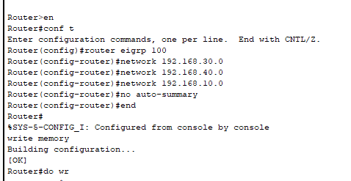
—----------------------------------------------------------------
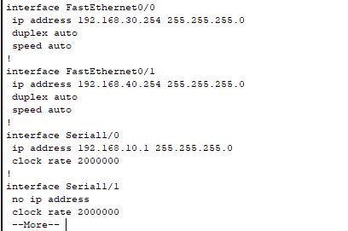
Router 2:
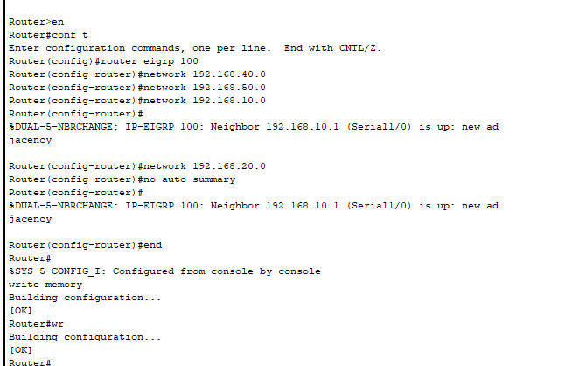
—-------------------------------------------------
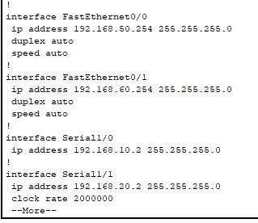
Router 3:
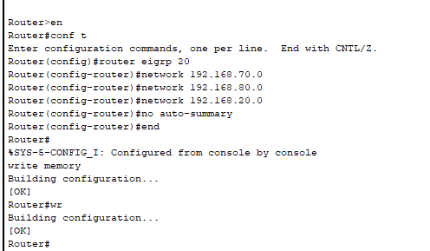
—---------------------------------------------------
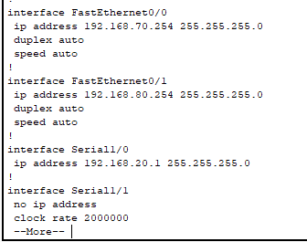
- Ping from PC 1 to PC 6
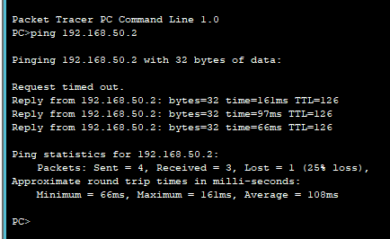

- Ping from PC 2 to PC 11
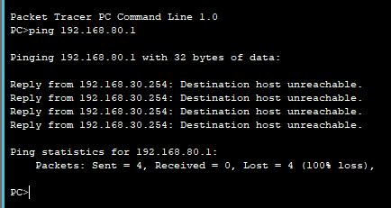

Question 3
Two routers are connected in a line; each router has two switches, and each
switch has two PCs. Configure OSPF. Make the serial interface a backbone
area and the FastEthernet ports non-backbone areas with different area
numbers. Check whether the PCs can communicate.

Router1:
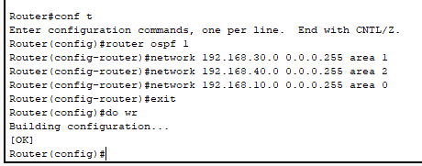

Router 2:
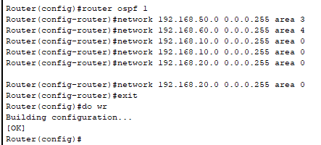
Router 3:
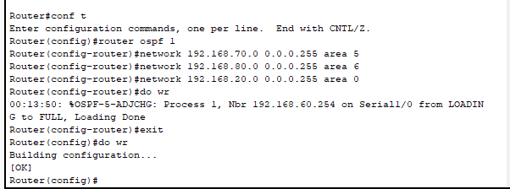

- Ping from PC 1 to PC 8
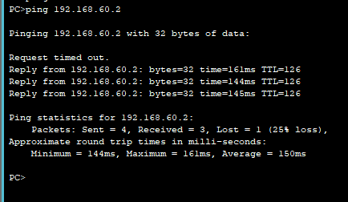

- Ping from PC 2 to PC 11
